
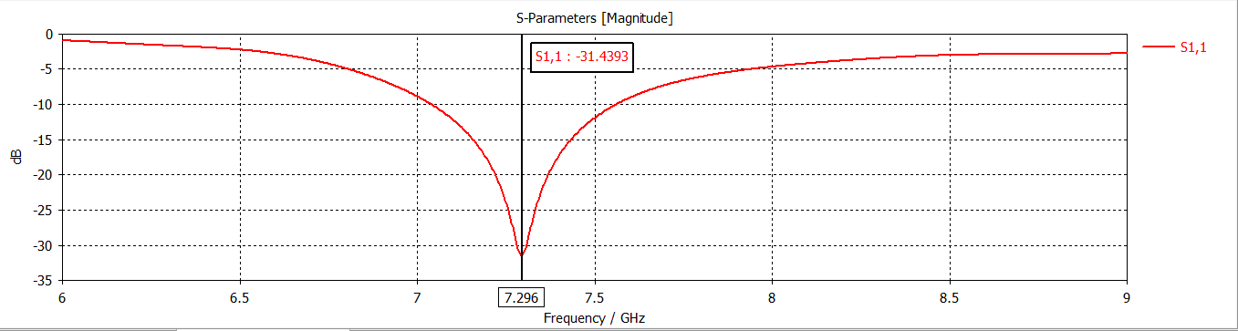
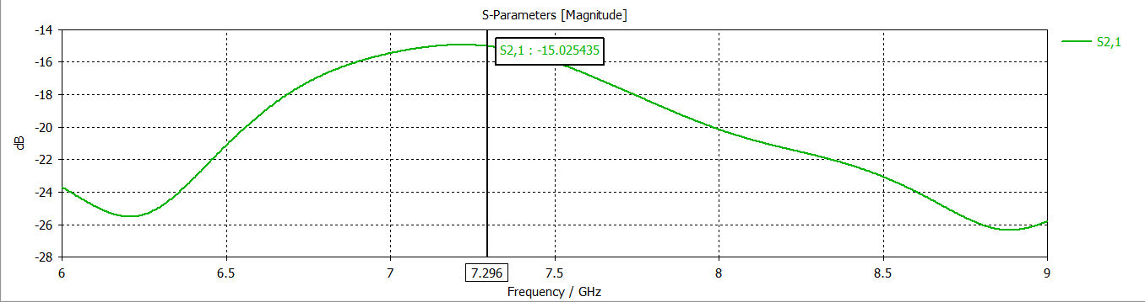
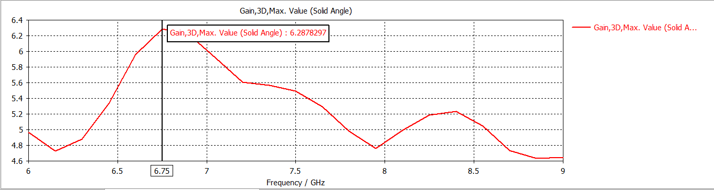
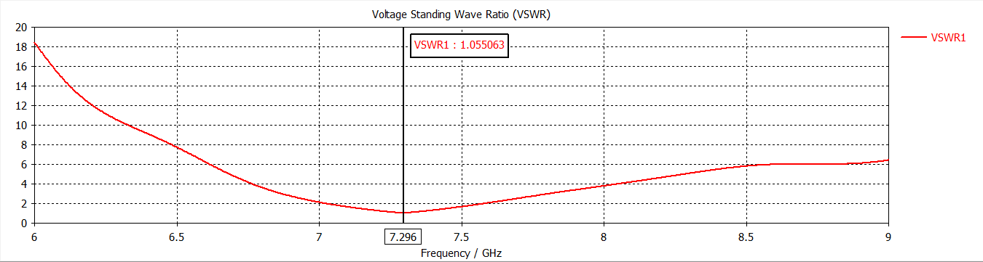

MALAVIYA NATIONAL

INSTITUTE OF TECHNOLOGY [MNIT] JAIPUR

Minor Project Report

ECE DEPARTMENT

Topic:

MIMO configuration using Cylindrical DRA

Submitted To – Dr. Reena Kumari Mam

Submitted By:

Aditya Kulshreshtha
2022UEC1517 EC-2
Project Report: Cylindrical Dielectric Resonator Antenna (CDRA) Design with Gain Enhancement

Abstract

This project introduces a modified cylindrical dielectric resonator antenna (CDRA) with a focus on S – parameters & gain enhancement and improved coupling between antenna elements. The original concept, derived from a cuboidal dielectric resonator antenna (DRA) design, was restructured to include cylindrical geometry, a direct-feedline mechanism, and a dielectric slab for gain improvement. The design operates at 7.3 GHz and utilizes lossy materials, such as Rogers RT5870 for the substrate and Rogers RO3010 for the patch, ensuring both high performance and material compatibility. Through computational modeling and simulation, the proposed antenna demonstrates significant improvements in gain, bandwidth, and coupling efficiency compared to its predecessor.

Introduction
The increasing demand for efficient communication systems in 5G and other wireless technologies necessitates innovative antenna designs. Dielectric resonator antennas (DRAs) have emerged as strong candidates due to their low ohmic loss, high radiation efficiency, and compact structure. While the original design in the reference paper focused on cuboidal DRAs for 5G mm-wave applications, this project explores the cylindrical variant with added performance-enhancing features.
The project objectives include:
- Redesigning the DRA geometry from cuboidal to cylindrical to leverage rotational symmetry.
- Improving gain by incorporating a dielectric slab between two antenna elements.
- Simplifying the feedline mechanism by using direct feeding to reduce complexity and loss.
This report elaborates on the design methodology, simulation results, and performance analysis of the proposed CDRA, demonstrating its viability for advanced communication systems.

Design Methodology

1. Geometry and Structure
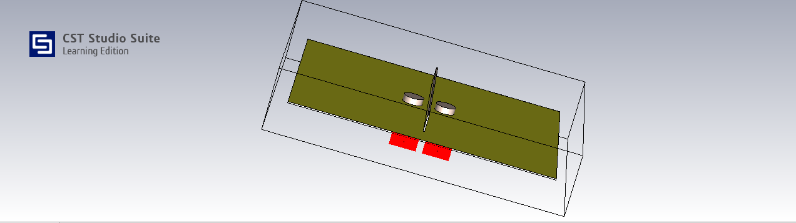
The proposed antenna design consists of:
- Cylindrical Dielectric Resonators: Two identical CDRAs with optimized dimensions to operate at 7.3 GHz.
- Substrate: Rogers RT5870 (lossy) with a dielectric constant of εr=2.33 .
- Patch Material: Rogers RO3010 (lossy), selected for its favorable electrical properties at the operating frequency.
- Dielectric Slab: Positioned between the CDRAs to enhance coupling and improve the overall gain.
- Feedline: A direct microstrip feedline without bending, simplifying the feeding mechanism and minimizing feedline losses.

2. Design Modifications
The primary modifications compared to the reference design are:
- Geometry: Cylindrical geometry replaces cuboidal DRAs to achieve better symmetry and reduced edge effects.
- Coupling Enhancement: The dielectric slab acts as a coupling medium between the resonators, reducing mutual impedance and boosting performance.
- Feedline Optimization: The direct feedline design eliminates unnecessary bends, reducing transmission losses.

3. Operating Frequency
The resonator dimensions were calculated to achieve resonance at 7.3 GHz using established analytical methods for cylindrical resonators. The geometry and material properties were fine-tuned to ensure optimal performance within the desired frequency band.

Material and Manufacturing Considerations
The materials selected for the antenna components play a crucial role in its performance:
- Ground Plane: Made of copper (Cu), ensuring excellent conductivity and low surface resistance.
- Substrate: Rogers RT5870 provides mechanical support and low-loss characteristics, making it suitable for high-frequency applications.
- Dielectric Slab: Designed to complement the CDRA’s material, ensuring enhanced coupling and minimal insertion loss .Made up of FR-4.

The antenna was fabricated using precise machining and PCB manufacturing techniques, ensuring dimensional accuracy and adherence to design specifications.

Simulation and Modeling

1. Simulation Software
The antenna design was simulated using CST Studio Suite, a leading tool for electromagnetic simulations. The software was utilized to:
- Optimize the resonator dimensions.
- Analyze the electromagnetic field distribution.
- Evaluate the scattering parameters and radiation patterns.

2. Key Simulation Results
- Reflection Coefficient (S11): The antenna achieved an S11 value below -10 dB across the operating bandwidth, indicating excellent impedance matching.
- Gain: A notable increase in gain was observed, attributed to the dielectric slab enhancing energy transfer between the resonators.
- Isolation: While not a primary focus of the design, the isolation between the two elements remained within acceptable limits.

Here, we are getting a dip of 31.44dB at a frequency of 7.296 GHz.

Here, we are getting a peak of 15.02dB at a frequency of 7.296 GHz.

Performance Analysis

1. Impedance Bandwidth
The antenna achieved a bandwidth of approximately 7.03 GHz to 7.56 GHz, covering the intended operating frequency of 7.3 GHz. This range ensures compatibility with various communication standards.

2. Gain Enhancement
The dielectric slab improved the antenna gain by redistributing the energy more effectively between the two resonators. The simulated gain was approximately 6.28 dBi, a significant improvement over the reference cuboidal DRA.

3. Radiation Patterns
The antenna exhibited stable and symmetric radiation patterns due to the cylindrical geometry. The patterns were consistent across the operating bandwidth, with minimal distortion or side lobes.

4. Mutual Coupling
The introduction of the dielectric slab reduced mutual coupling between the antenna elements, enhancing their independent operation. This is critical for applications requiring MIMO configurations.

Here , we are getting a gain of 6.287dB at 6.75 GHz

Here, we are getting a VSWR of 1.05 at the resonant frequency.

Comparison with Reference Design
Feature | Reference (Cuboidal DRA) | Proposed (Cylindrical DRA)
Geometry | Cuboidal | Cylindrical
Feeding Mechanism | Microstrip-fed bent slots | Direct microstrip feedline
Gain | 8 dB | 6.29 dB
S11 | -42dB | -31.43dB
Material | Rogers RT5880 | Rogers RT5870, RO3010,FR-4
Coupling Enhancement | None | Dielectric slab

Applications
The proposed CDRA design is well-suited for:
- 5G Communications: Its high gain and low-loss characteristics make it ideal for base stations and small cells.
- IoT and Sensor Networks: Compact size and efficient performance support a wide range of IoT applications.
- Satellite Communication: The antenna's ability to operate at GHz frequencies makes it suitable for satellite uplink and downlink systems.

Conclusion and Future Work
The redesigned cylindrical dielectric resonator antenna demonstrates significant improvements in s parameters and coupling efficiency while maintaining a simple and manufacturable structure. The addition of a dielectric slab and the use of direct feedlines have contributed to the enhanced performance. Future work may involve:
- Experimenting with advanced feeding techniques for further gain enhancement.
- Experimenting with different slot shapes and sizes for better feeding.

References
- Yin Zhang et al., A MIMO Dielectric Resonator Antenna with Improved Isolation for 5G mm-Wave Applications, IEEE, 2019.
- CST Studio Suite Documentation, Dassault Systèmes.

